GHS Updates for University Campuses - 2026
Starting January 19, 2026, U.S. universities must comply with OSHA’s updated Hazard Communication Standard (Hazcom), which aligns with the UN’s Globally Harmonized System (GHS). This means new rules for Safety Data Sheets (SDSs), chemical labeling, and centralized management systems on campuses.

Key Points (2026)
- Compliance Deadlines
  - January 2026: Chemical manufacturers, importers, and distributors must comply for substances.
  - July 2027: Compliance for mixtures.
  - Universities using chemicals must align with these timelines.
- Alignment with GHS Rev. 7 & Rev. 8
  - Updated hazard classes and categories.
  - Revised criteria for physical and health hazards.
  - Enhanced clarity in SDSs and labels.
- Safety Data Sheets (SDSs)
  - New format requirements for hazard classes.
  - Confidential business information rules updated.
  - Universities must ensure SDSs are accessible and current.
- Labeling Changes
  - More precise hazard pictograms and signal words.
  - Revised shipping requirements for chemicals.
- Campus-Specific Implications
  - Universities are complex ecosystems with labs, maintenance, and custodial operations all using chemicals.
  - Centralized SDS management systems are strongly recommended to ensure compliance, reduce risk, and improve efficiency.
  - AI-powered and cloud-based SDS platforms are emerging as best practice for 2026.

Comparison Table: Old vs. New Hazcom
Aspect | Pre-2026 Standard (Rev. 3) | Post-2026 Standard (Rev. 7/8)
Hazard Classes | Limited, less precise | Expanded, clearer definitions
SDS Format | 2012-style, less uniform | Updated with new hazard classes
Labels | Basic pictograms & words | Revised symbols, stricter wording
Confidential Info | Less protection | Stronger rules for trade secrets
Compliance Timeline | Already in effect | Substances: Jan 2026; Mixtures: Jul 2027
Campus Management | Often decentralized | Push for centralized SDS systems

Risks & Challenges
- Non-compliance penalties: OSHA fines & insurance citations if SDSs or labels are outdated.
- Operational disruption: Labs and facilities may face delays if chemical shipments don’t meet new labeling rules.
- Training needs: Faculty, staff, and students must be retrained on updated hazard classes and pictograms, as updates are released. (We retrain annually)

How to Access Safety Data Sheets at UL
The University of Louisiana at Lafayette utilizes a free software program to access Safety Data Sheets. All spaces that store chemicals should have electronic access to Safety Data Sheet information. You can download this program using the University’s Software Center.
- Type Software Center into the search bar of your computer to access computer programs that are ready for download. (See below)
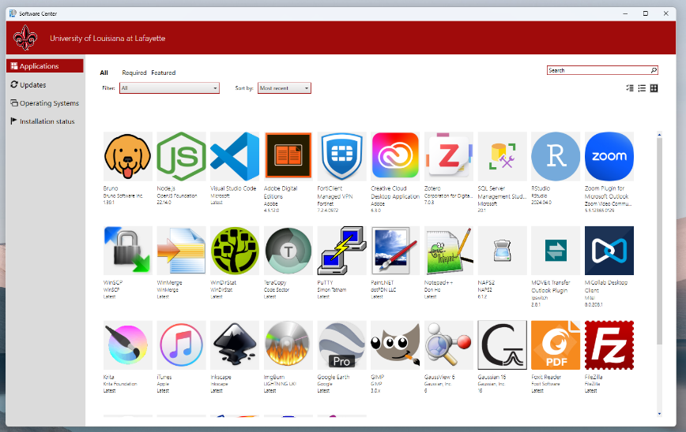
- Search for CAMEO Chemicals. This is the free program used by the University to access Safety Data Sheet information.
- Follow the steps to safely install this on your computer.
In addition, graduate students, researchers, faculty, and staff can access this free program on their mobile device by downloading the CAMEO Chemicals App for IOS on the App Store or for Android on Google Play.
